PRACTICAL 9

Aim:
To draw the Data flow diagram for <case study name>:

Theory:
A data flow diagram (DFD) maps out the flow of information for any process or system. It uses defined symbols like rectangles, circles and arrows, plus short text labels, to show data inputs, outputs, storage points and the routes between each destination. Data flowcharts can range from simple, even hand-drawn process overviews, to in-depth, multi-level DFDs that dig progressively deeper into how the data is handled. They can
be used to analyse an existing system or model a new one. Like all the best diagrams and charts, a DFD can often visually “say” things that would be hard to explain in words, and they work for both technical and nontechnical audiences, from developer to CEO.
That’s why DFDs remain so popular after all these years. While they work well for data flow software and systems, they are less applicable nowadays to visualizing interactive, real-time or database-oriented software or systems.
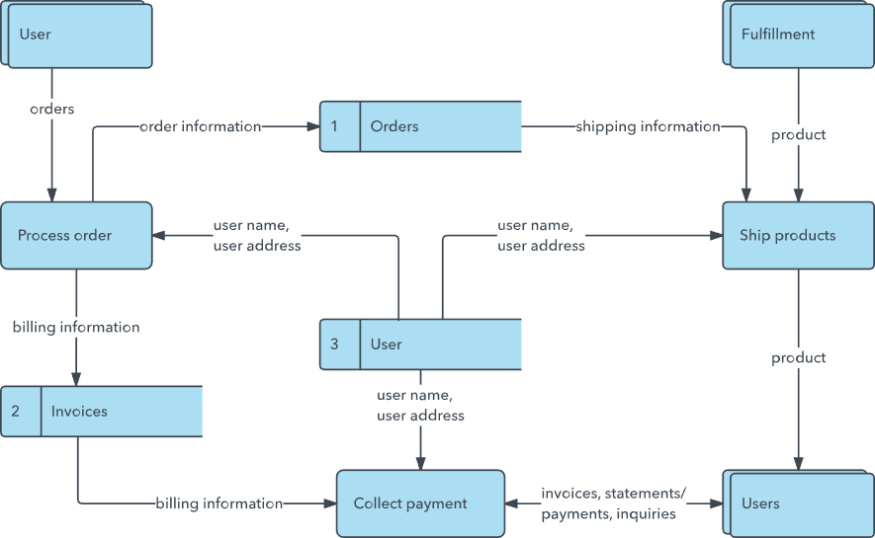

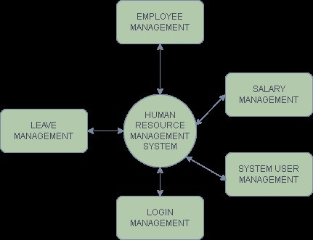
example Output: A data flow diagram of the system. Level 0

Level 1
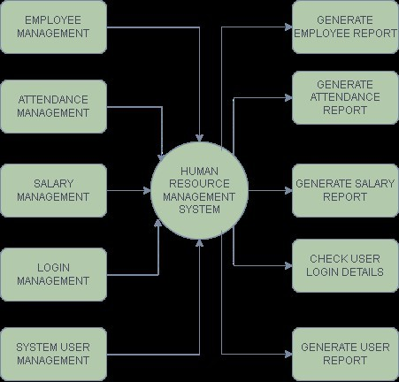

PART -B
DEVELOP DFD LEVEL 0 AND LEVEL 1 FOR YOUR MINI PROJECT

Name: | Roll No:
Batch: | Date:

